Lab 6.6 Jobs

1. Create a job.yml file as shown below:

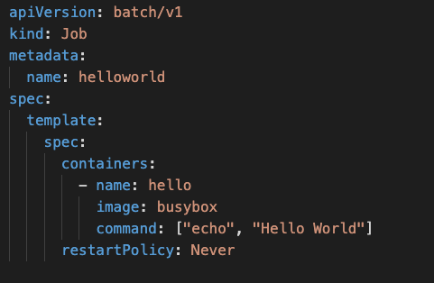

1. Create a Job

**kubectl create -f job.yml**

1. Check the completion status of the job

**kubectl get jobs**

1. Have a look at the logs of the Pod

**kubectl logs -f <podName>**

1. Have a look at more details of the Job

**kubectl describe job**

1. Delete the Job

**kubectl delete job helloworld**

1. Add the completions and set it to value 2

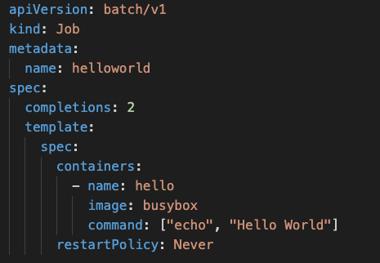

1. Create the Job and test how many times it executes

**kubectl create -f job.yml**

**kubectl get jobs**

1. Delete the Job

**kubectl delete job helloworld**

1. Add Parallelism to the job

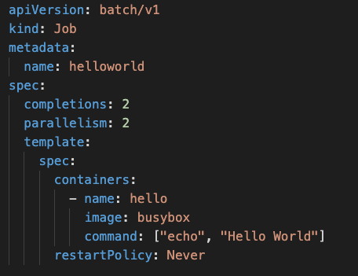

1. Create the Job

**kubectl create -f job.yml**

1. Check that 2 pods get executed at one go in parallel

**kubectl get all**

1. Delete the Job

**kubectl delete job helloworld**

1. Change the command so that it fails and notice how many time it restarts

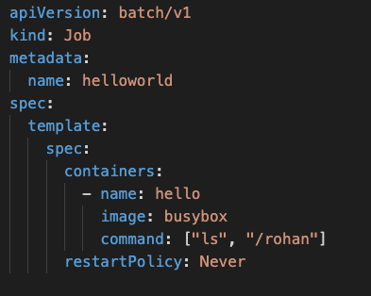

1. Create the Job again and check status. Because of the error it will go on creating a new pod infinitely till the job is getting failed

**kubectl create -f job.yml**

**kubectl get all**

1. Delete the job again

**kubectl delete job helloworld**

1. Set the backoffLimit to limit the number of times it restarts because of failure

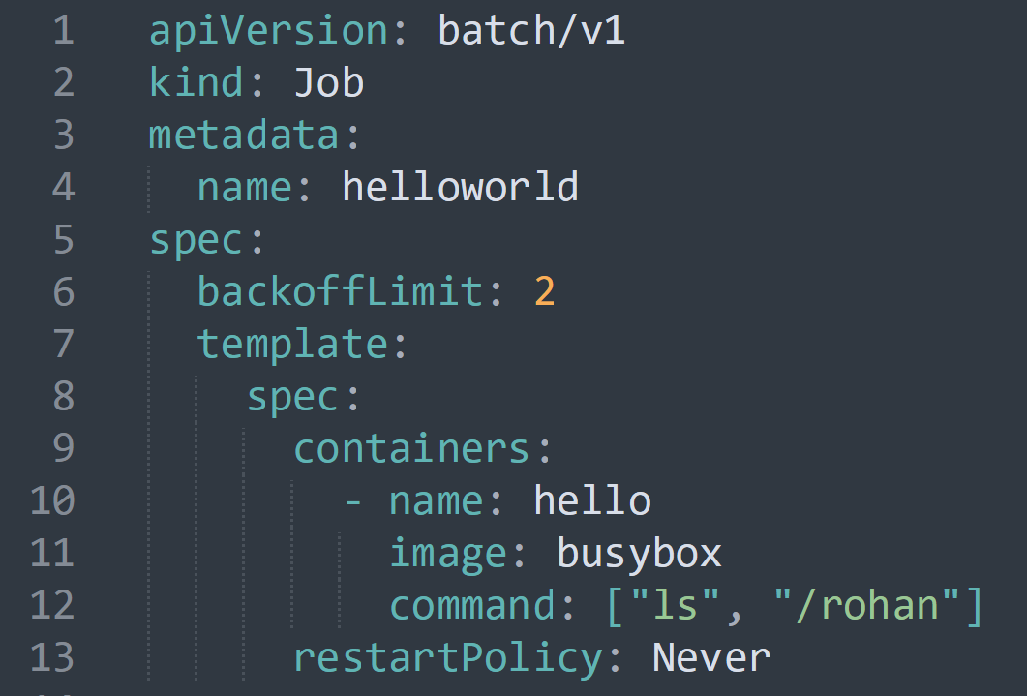

1. Create the Job and check the Number of restarts is set to a number

**kubectl create -f job.yml**

**kubectl get all**

1. Delete the job

**kubectl delete job helloworld**

1. Add a time limit to how long a job should execute and if it crosses this limit, fail the job

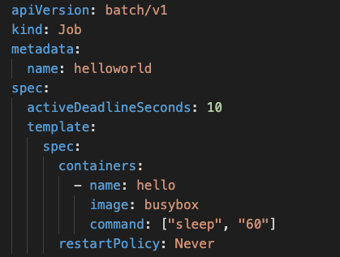

1. Create the Job and check the status

**kubectl create -f job.yml**

**kubectl get all**